Advanced Technologies Rendering Techniques

Abstract
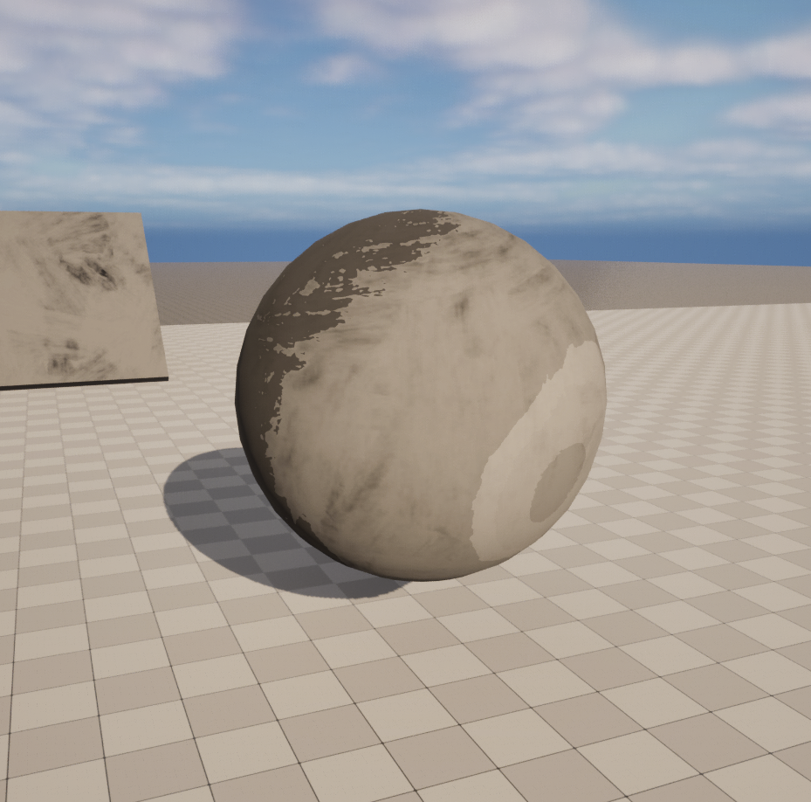It would be suitable to put a picture or something representative of outcome or process here
Alex Fiddament
Department of Computer Science and Creative Technologies
University of the West of England
Coldharbour Lane
Bristol, UK
Alexander.2Fiddament@uwe.ac.uk
21007266

There are many different art styles that have been used for a wide range of media such as animation, comic books, games and many more. In this report I explore how to recreate a paint inspired visual style at runtime using a range of techniques, making use of unreal engines tools.

Author Keywords
Authors’ choice; of terms; separated; by semi-colons
Optional section to be included in your final version, but strongly encouraged.

Introduction

The task we were given is “what other media styles can be recreated during runtime”. The aim of this project was to try to recreate a style of our choice during runtime using various techniques to try achieve this aesthetic. The style I decided to try to replicate during runtime was a paint style. I chose this stye as its not commonly used in many real time renders so it makes it a unique challenge.
The engine of choice for this project was unreal engine so I could make use of its powerful render and wide variety of tools available. This allows me to experiment with all the different material functions to create an effect that matches my goal. My goal is to create a material similar to wet paint, that has a fluid and reflective feel.

Background Research
My initial research showed me many different games with a painted style where they were all very distinct from each other, some of the games I looked at were okami and . This led me to find a project by where he made a paint material in unreal engine

Methods
Firstly I used project as reference and used the same texture (the texture shown below) for my base texture
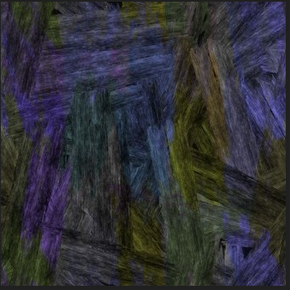
I wanted to add in brush strokes to my paint texture, this is because paint, even when it is dry you are able to see the brush strokes left over. The way that I included this into the material was by taking the b node of the texture and multiplying it with a value to make the brush strokes more pronounced. Then I have two parameters that are used for the primary color and the brush stroke color. I then pass the primary color into the a input of a lerp the brush color into the b input of the lerp and the result of the multiply node into the alpha of the lerp. I then multiply this result with my lighting changes and use a lerp to combine it with my reflection.
Another feature of the material is the shadows on the material. I achieved this by

Then I wanted to add some depth to the brush strokes, this gives it a 3d appearance and adds extra detail. I found that this could be done in 2 ways, either bump offset or by using parallax occlusion mapping. The method I chose to use was bump offset where I use the texture sample blue channel as the height. Then after adjusting the height ratio input I achieved a depth I was happy with. This also gave it a slightly shiny effect on the surface of the material.
In addition to this I wanted to add more movement to the texture. Initially I added a Gaussian Blur to the texture by getting 4 samples of the texture and adding a small value to each of the UVs to create a blur effect. This did not accomplish what I wanted so I tried a different method.
The next method I tried was a texture mask, this was done by getting the texture coordinates then using length to calculate the distance from the center. Then using the power node gives it exponential drop off and I clamp the value to keep it between 0 and 1. This goes into the alpha of the lerp node, for the first input of the node I used a grayscale version of my texture. For the second input I would get the texture coordinates and subtract them from the mouse coordinates, then multiply them by the desired brush size. This did not work as the greyscale texture returned a float 3 and the mouse position returned a float 2. I tried converting the floats to match each other but this did not give the intended effect either.
The final method I tried was by subtracting the world position by the camera position, I then convert this result into a float 2 and normalize it. Afterwards I multiply it by the value you want it to move by, I chose a small value as I only want slight movements. I then put this value into my base textures UVs and now the texture moves slightly with the camera.
I wanted to add to this wet effect by adding reflections onto the material. I did this to enhance the realism of the material and add to the shiny look. The way I did this was by getting the texture coordinates and using a swizzle on the texture sample, this pivots the normal map and ensures that I wont get the same pattern as the brush strokes. Then I calculated the reflection vector by comparing the normalized light direction to the surface normal of the material. Then I used a dot node to measure the angle between the two vectors, this helps me determine the strength of the reflection compared to the camera. I then use power and clamp nodes to control final appearance of the reflection. then I multiply the result by 0.5 to reduce the opacity of the reflection and use a lerp to combine the reflection with the brush strokes pattern. The color of the reflection is also able to be controlled by two parameters, this is to give you full customizability over the colors in the paint just like the base color.

Outcomes
The outcomes of this project show how I went about successfully creating a paint effect during runtime in unreal with a shiny and fluid feel to it. The texture moving under the paint works well, giving it a dynamic feeling and the stylized shading and reflections all add to the paint aesthetic.

Evaluation
Even though I achieved my goal in creating a paint shader during runtime there are several areas where I did not accomplish what I wanted, firstly the SDF occlusion does not use the texture sample like I wanted and instead is just a block color

(Delete this section before submission!)

Figure 1. Insert a caption below each figure.
Column Head Samples | 1 | 2 | 3
Measurements result | 22.52 | 12.16 | 10.75
CogTool prediction | 22.72 | 12.26 | 10.60
CogTool error % | 0.009 | 0.008 | 0.014
Table 2. This sample table has the caption appearing below. Please use 0.75 rules/borders for your tables, align decimals or center text in the cells. For improved accessibility, header rows of tables should be marked. In Word, right click a header row, and select Table Properties | Row | Repeat as header at the top of each page.
As for the “picture” tab in that dialog, we recommend using Photoshop or other graphics software to scale images, rather than scaling them after you have placed them in Word. Word’s scaling tends to reduce the clarity and legibility of images more so than dedicated graphics software.
One good use of the narrow margin column: callouts that annotate a figure, either with text or a more detailed image.
Figure 2: If your figure has a light background, you can set its outline to light gray, like this, to make a box around it. The column width is 8.5 cm (3.34”), so setting this picture to fill the column was easily done by right-clicking on it (option-click on the Mac), choosing “format picture,” then the “size” tab, and setting its width to 8.5 cm (3.34”).
Good Utilization of this Space Sample, as Side Bar
Preparation: Do not change the text box size or position.
Materials: This can not appear higher or lower on the page because of pagination and specific headers added during the indexing and pagination process.
Process: A 0.75 inch rule is beneficial to break this apart from the body text. The text in this text box should remain the same size as the Body Text: 8.5 Verdana or Arial (with use of bold and italics to highlight points)
Images & Figures: If you have any images in color, it is always good practice to print your paper out in black and white to ensure that the tones and screens used in your figures reproduce well in black and white, but your images will appear in full color in the electronic proceedings and in the ACM digital library. Images in your document should be at least 300 or 600 dpi for quality reproduction.
Page five shows a treatment of large figures, too big to fit inside a single column of text.
All figures should include alt text for improved accessibility. In Word, right click the figure, and select Format Picture | Alt Text).

References and Citations

(Delete this section before submission)
You should be using the Harvard Referencing system as specified by the University Guidelines (see Library website for more information)
Your references should be published materials accessible to the public. Internal technical reports may be cited only if they are easily accessible (i.e., you provide the address for obtaining the report within your citation) and may be obtained by any reader for a nominal fee. Proprietary information may not be cited. Private communications should be acknowledged in the main text, not referenced (e.g., “[Robertson, personal communication]”).

Accessibility

(Delete this section before submission)
The Executive Council of SIGCHI has committed to making SIGCHI conferences more inclusive for researchers, practitioners, and educators with disabilities. As a part of this goal, the all authors are asked to work on improving the accessibility of their submissions. Specifically, we encourage authors to carry out the following five steps:
- Add alternative text to all figures
- Mark table headings
- Generate a tagged PDF
- Verify the default language
- Set the tab order to “Use Document Structure”
For more information and links to instructions and resources, please see:
So long as you don’t type outside the right margin, it’s okay to put annotations over here on the right, too. Remember to use the annotation text style.

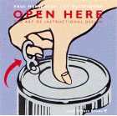

References
 | Center column head | Center column head
child | 4.2 | 2.3 | 5.1 | 3.8
older adults | 2.8 | 2.2 | 3.1 | 4.7
Bob | 2.5 | 3.1 | 3.0 | 12.2
Dave | 0.75 rules | 2.5 | 3.2
Table 1. Sample narrow table in the left margin space.
Adobe Acrobat Reader 7. http://www.adobe.com/products/acrobat/.
Anderson, R.E. Social impacts of computing: Codes of professional ethics. Social Science Computing Review 10, 2 (1992), 453-469.
How to Classify Works Using ACM’s Computing Classification System.
http://www.acm.org/class/how_to_use.html.
Klemmer, R.S., Thomsen, M., Phelps-Goodman, E., Lee, R. and Landay, J.A. Where do web sites come from? Capturing and interacting with design history. In Proc. CHI 2002, ACM Press (2002), 1-8.
Mather, B.D. Making up titles for conference papers. Ext. Abstracts CHI 2000, ACM Press (2000), 1-2.
Schwartz, M. Guidelines for Bias-Free Writing. Indiana University Press, Bloomington, IN, USA, 1995.
Zellweger, P.T., Bouvin, N.O., Jehøj, H., and Mackinlay, J.D. Fluid Annotations in an Open World. Proc. Hypertext 2001, ACM Press (2001), 9-18.
The 1998 ACM Computing Classification System. http://www.acm.org/about/class/1998

